Adding GEO Responses using Polygons

After logging in navigate to the Add Polygon page.

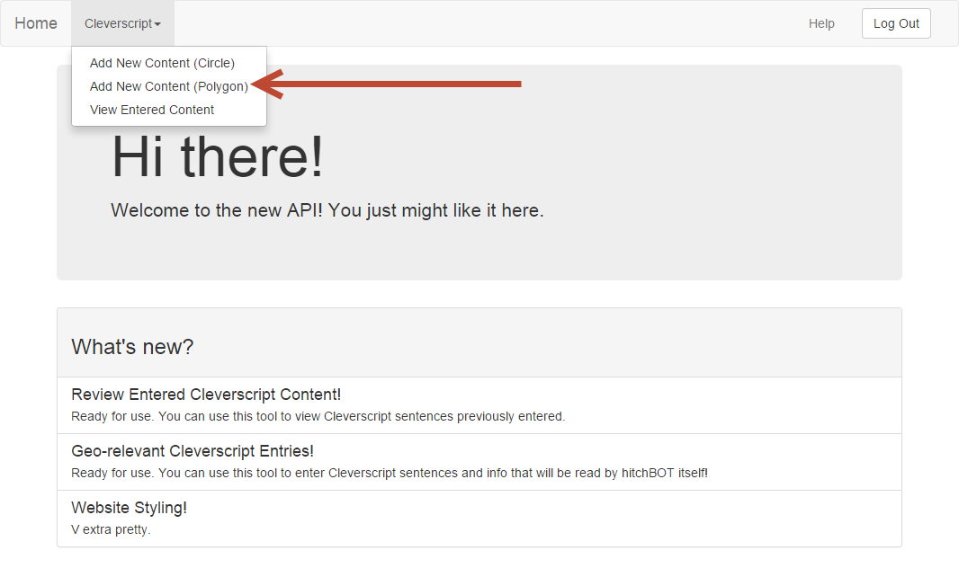

For this example we will select the State of Florida. First zoom over the area you wish to select.

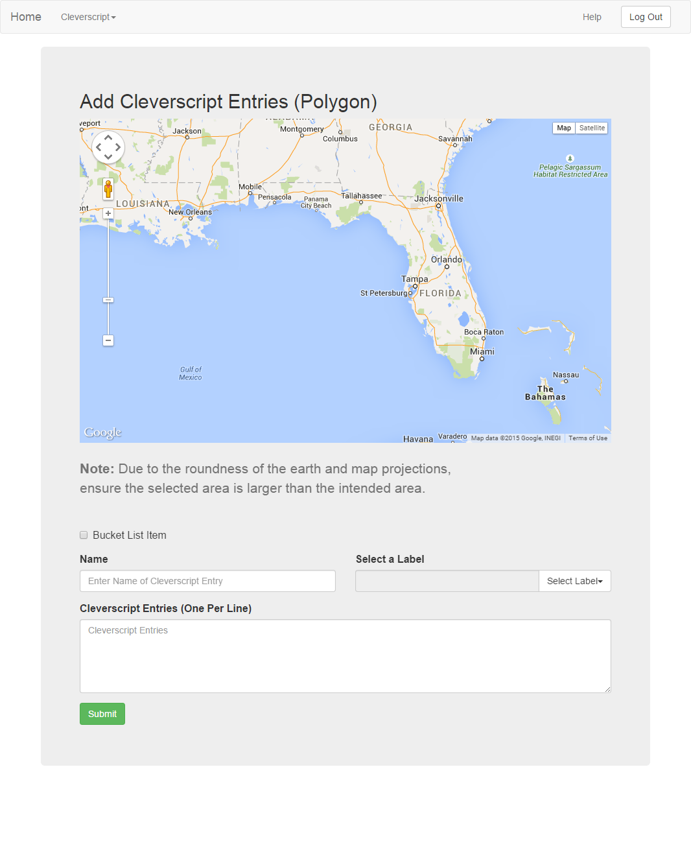

Start by placing a marker in the most top-right corner of the area you want to select. To place a marker single click the map. Note: the markers are not draggable!

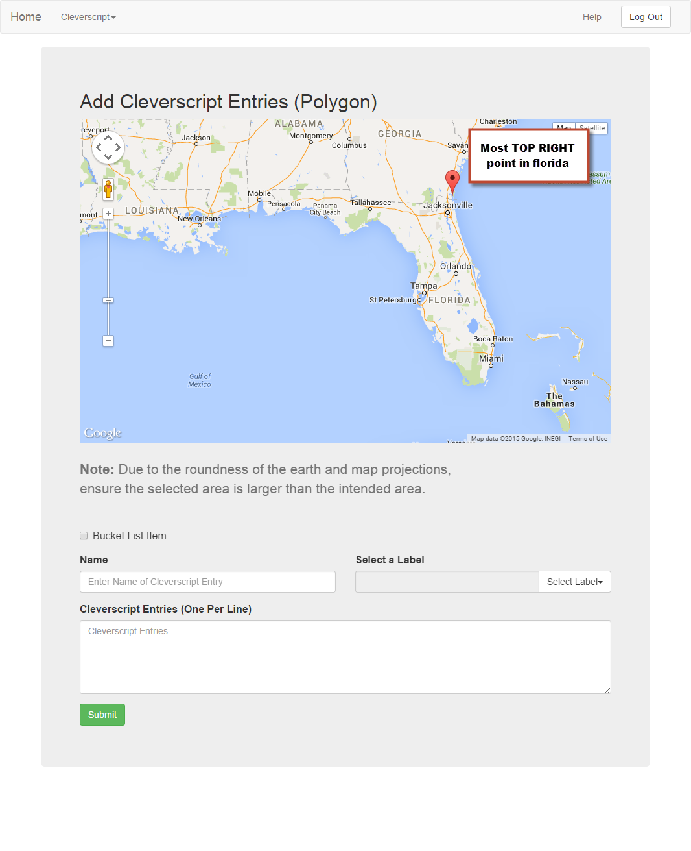

Proceed by placing additional markers in a clockwise motion tracing the border of the area you wish to select. Once three markers are placed it will start to show a polygon.

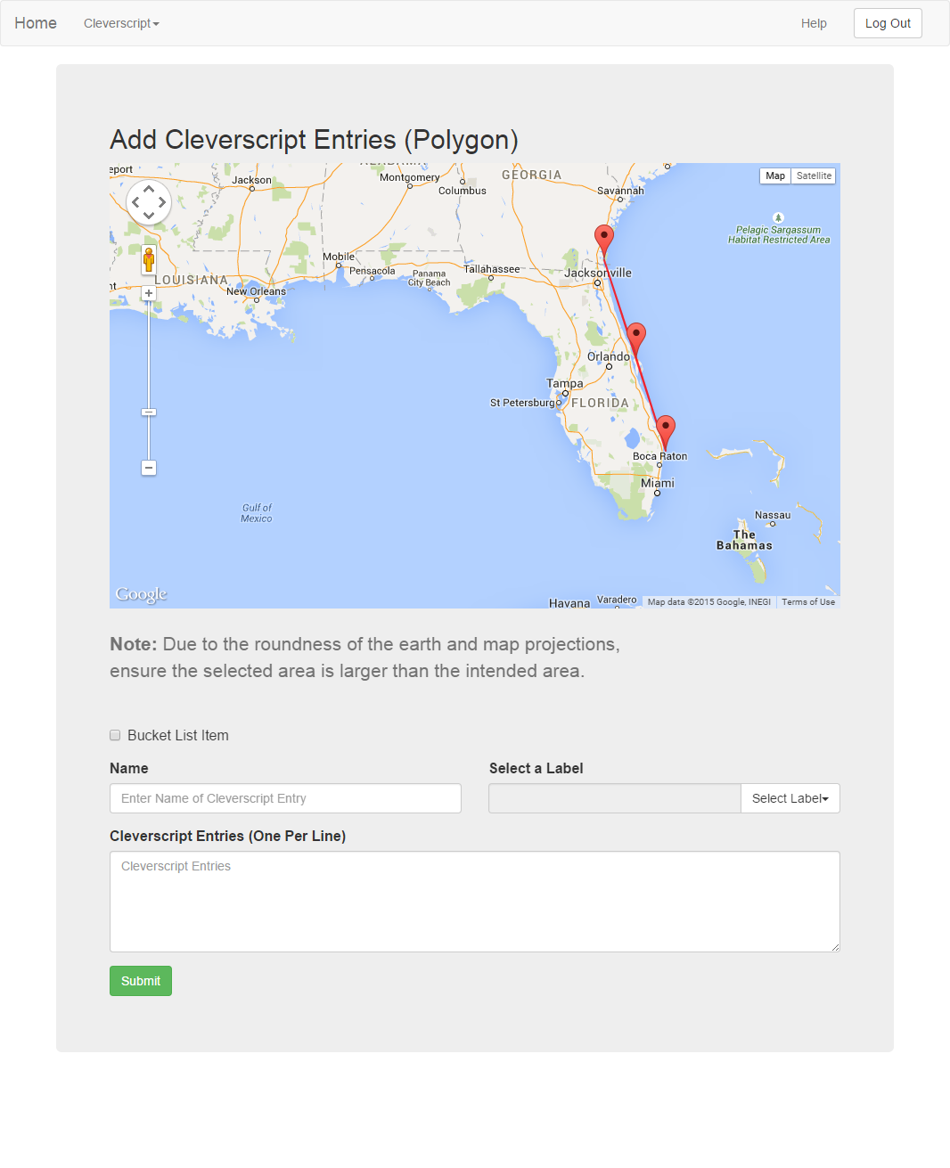

Continue adding markers until the first point is reached. It should look something like this. You can zoom in closer while placing markers if it is required.

Note: Do not worry about being extremely accurate with the placement. If you make a mistake you have to refresh the page. A polygon should not need more than 20 markers.

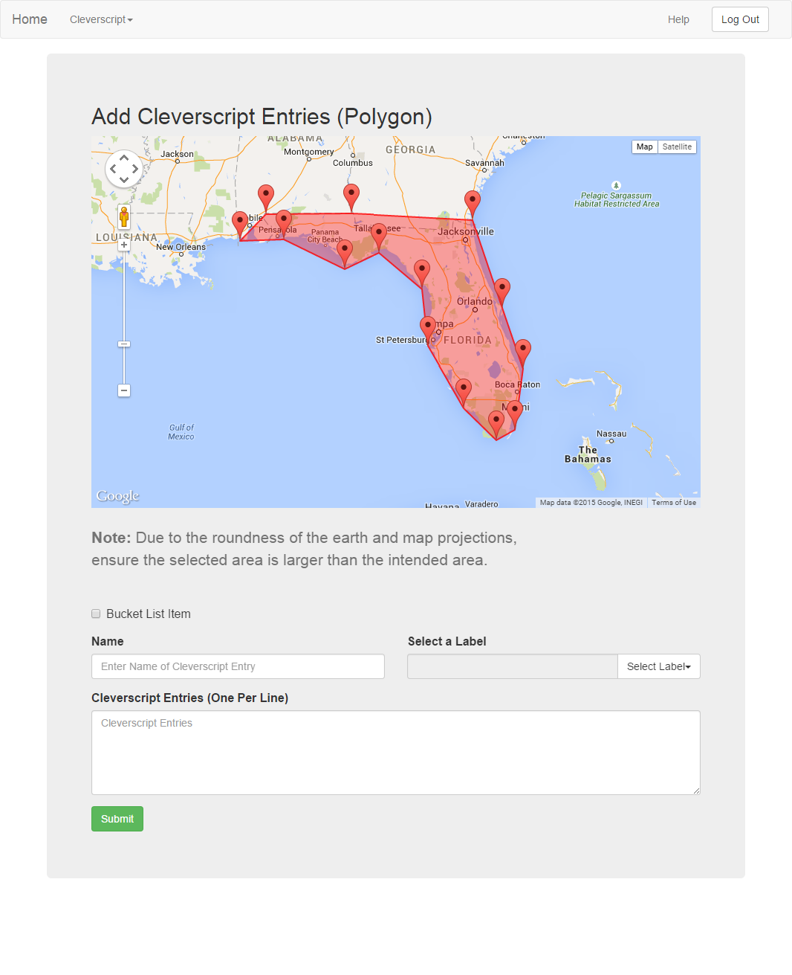

It is important that the edges of the polygon do not overlap itself. If your polygon looks like this then you must refresh the page and reselect the points

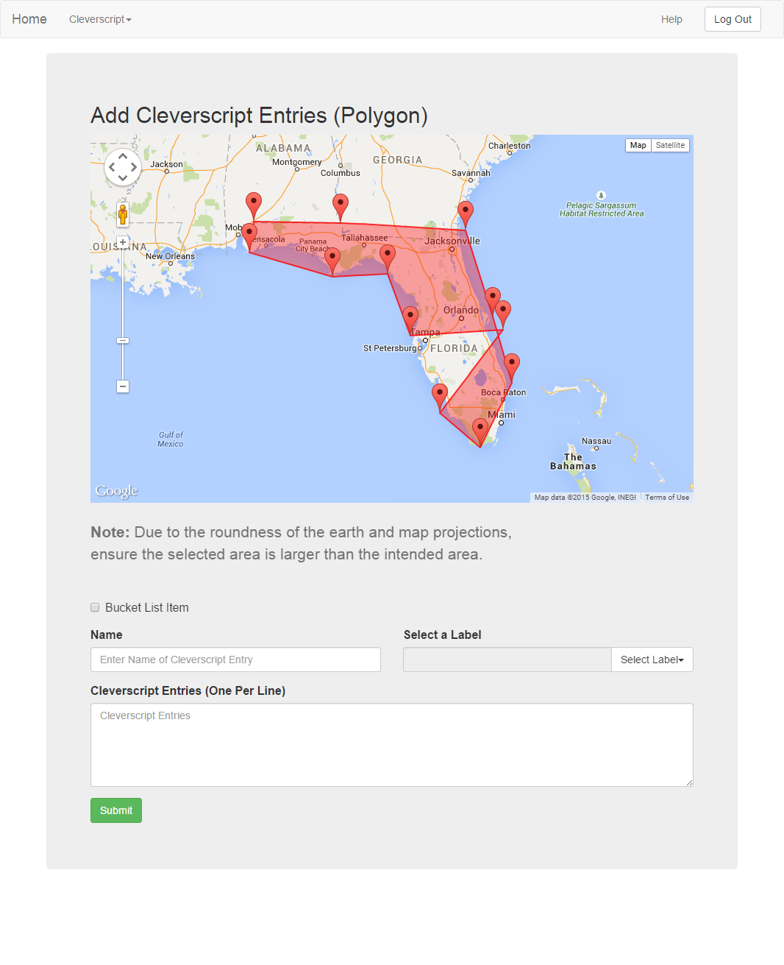

Next add the Name, Label and Cleverscript entries to tag to this location. If this entry is a bucket list item, check the checkbox.

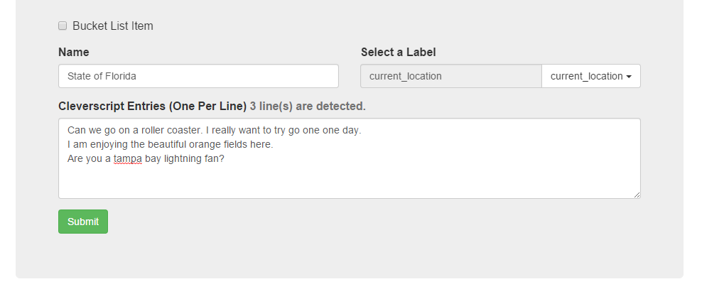

Hit submit and it will be added to the map! Hitchbot will now say this content when it is in the State of Florida!